**E-library Semantic Search**

**1. Overview**

This ontology models an **E-Library system** to organize books, authors, publishers, and topics. It enables semantic relationships for:

* Tracking authorship and co-authorship.
* Managing publication metadata (ISBN, format, language).
* Defining hierarchical topic classifications.

**2. Class Hierarchy and Relationships**

**Class Descriptions**

* **Book**: Represents books.
* **Author**: Writers of books.
* **Publisher**: Organizations/individuals publishing works.
* **Format**: File/print formats (e.g., PDF).
* **Topic**: Hierarchical categories (e.g., "Artificial Intelligence" is a subtopic of "Computer Science").
* **Hierarchy**

**3. Properties**

**3.1 Object Properties**

|  |  |  |  |
| --- | --- | --- | --- |
| Property | Domain | Range | Description |
| authorOf | Author | Book | Author of a book/article. |
| coAuthorOf | Author | Author | Co-authorship between authors. |
| hasFormat | Book | Format | Format of the publication (e.g., PDF). |
| hasTopic | Book | Topic | Topic associated with the work. |
| publishedBy | Book | Publisher | Publisher of the work. |
| subTopicOf | Topic | Topic | Hierarchical relationship between topics. |
| writtenBy | Book | Author | Inverse of authorOf. |

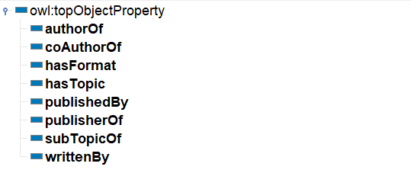

**3.2 Data Properties**

|  |  |  |  |
| --- | --- | --- | --- |
| Property | Domain | Range (XSD) | Description |
| ISBN | Book | integer | Unique identifier for books/articles. |
| language | Book | language | Language of the work (e.g., "english", "spanish"). |
| pageCount | Book | integer | Number of pages. |
| publicationYear | Book | dateTime | Publication date. |

**4. Instances (Individuals)**

**Key Examples**

1. **1984** (Book)
   * hasTopic: Dystopian
   * writtenBy: George_Orwell
   * publishedBy: Secker_Warburg
   * ISBN: 9780451524935
2. **The_Prophet** (Book)
   * hasFormat: Paperback
   * publishedBy: Kahlil_Gibran.
3. **Knowledge_Graphs_101** (Book)
   * hasTopic: Knowledge_Graph (subtopic of Artificial_Intelligence).

**5. Inferred Semantics and Rules**

**5.1 SWRL Rules**

**Rule 1: Topic Inheritance**

Inference: A book with subtopic Knowledge_Graph automatically inherits Artificial_Intelligence.

**Rule 2: Author of Books**

Inference: A book with an author inferred as the author of that book automatically.

**Rule 3: Publisher of Books**

Inference: A book published by a publisher inferred as the publisher of that book automatically.

**Rule 4: CoAuthor of books**

Inference: Authors who have collaborated on the same book inferred as co-authors automatically.

**5.2 SPARQL Queries**

**1. List Topics and Their Subtopics**

Shows which topics are subtopics of broader topics.  
Example: "Artificial_Intelligence" is a subtopic of "Computer_Science".

**2. Get Book Details**

Lists books with their ISBN, page count, and publication year.

**3. Find Books Published by MIT Press**

Returns all books published by "MIT_Press".  
Example: "Semantic_Web_Primer".

**4. Show All Book Formats**

Lists unique formats (e.g., PDF) available for books.

**5. Books Tagged Under "Computer_Science"**

Finds books directly linked to the "Computer_Science" topic.

**6. Visual Diagrams**

